**MOTION DETECTION SYSTEM**

**Using cps**

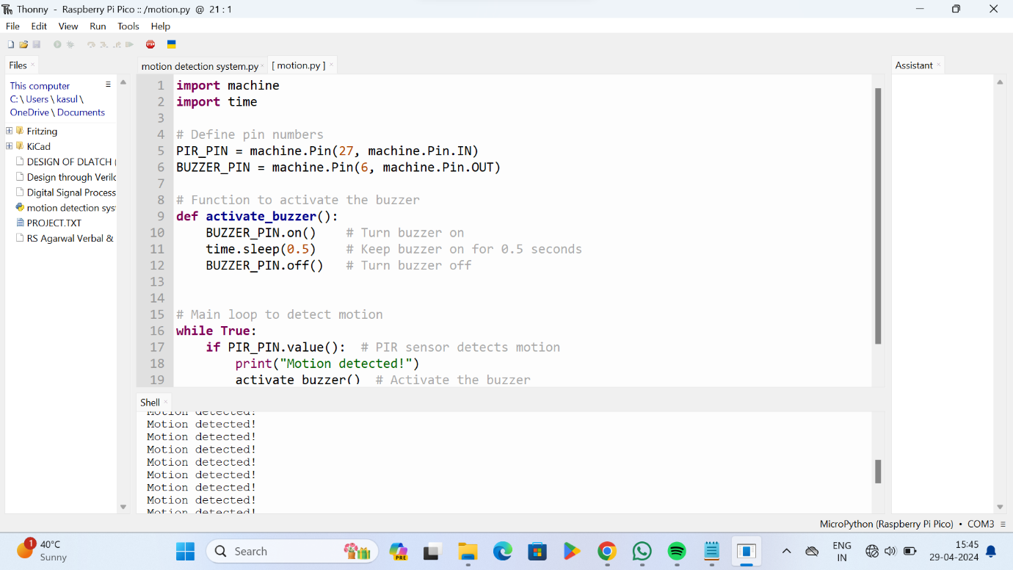

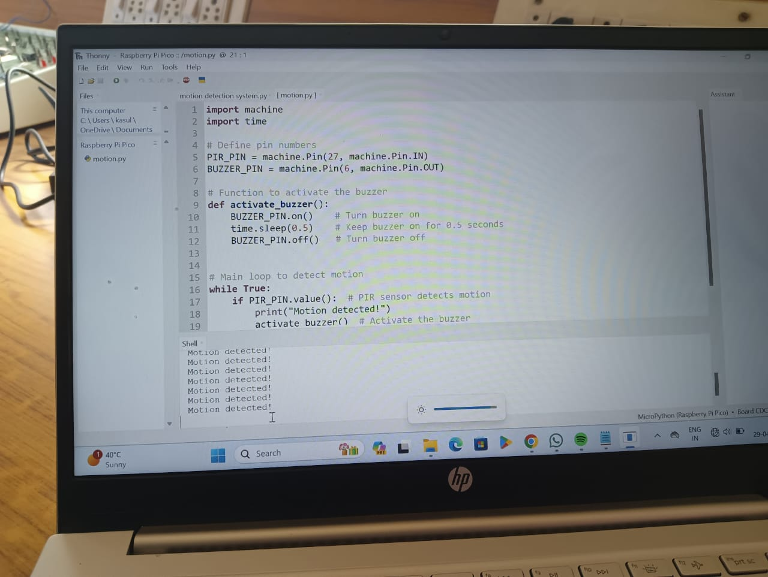

**BY**

**21781A04B5**

**21781A04B3**

**21781A04C0**

**21781A04C4**